Spectrometer App - User Manual

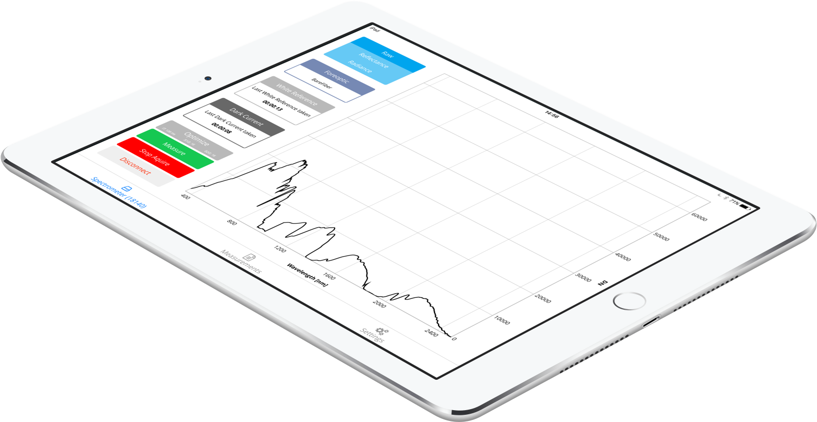

# Support Information

If you have any questions or concerns, please contact:

**Dr. Andreas Hueni**  
Remote Sensing Laboratories  
Department of Geography  
University of Zurich

[andreas.hueni@geo.uzh.ch](mailto:andreas.hueni@geo.uzh.ch)  
+41 44 635 65 16

Table of Contents

Support Information 1

Introduction 3

Connection 3

Calibration File Import 4

Start page 6

Add Spectrometer 6

Connect 7

Acquire Screen 8

Measurement Screen 10

Measurements 13

Export 14

Settings 15

# Introduction

The iOS App Spectrometer is compatible with the ASD devices Fieldspec 3 and Fieldspec 4. Requirement is a mobile device with iOS 10 or higher. Before you can start using the app you must establish a connection to the device and import the required calibration files.

# Connection

To connect the iOS Device with the spectrometer, make sure both devices are on and have enough power. Then go to the settings app on your iOS device.

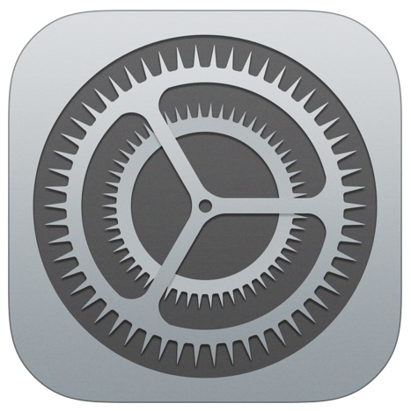

Then switch to the Wi-Fi menu. Select the wireless network which is named after the serial number of your ASD Spectrometer.

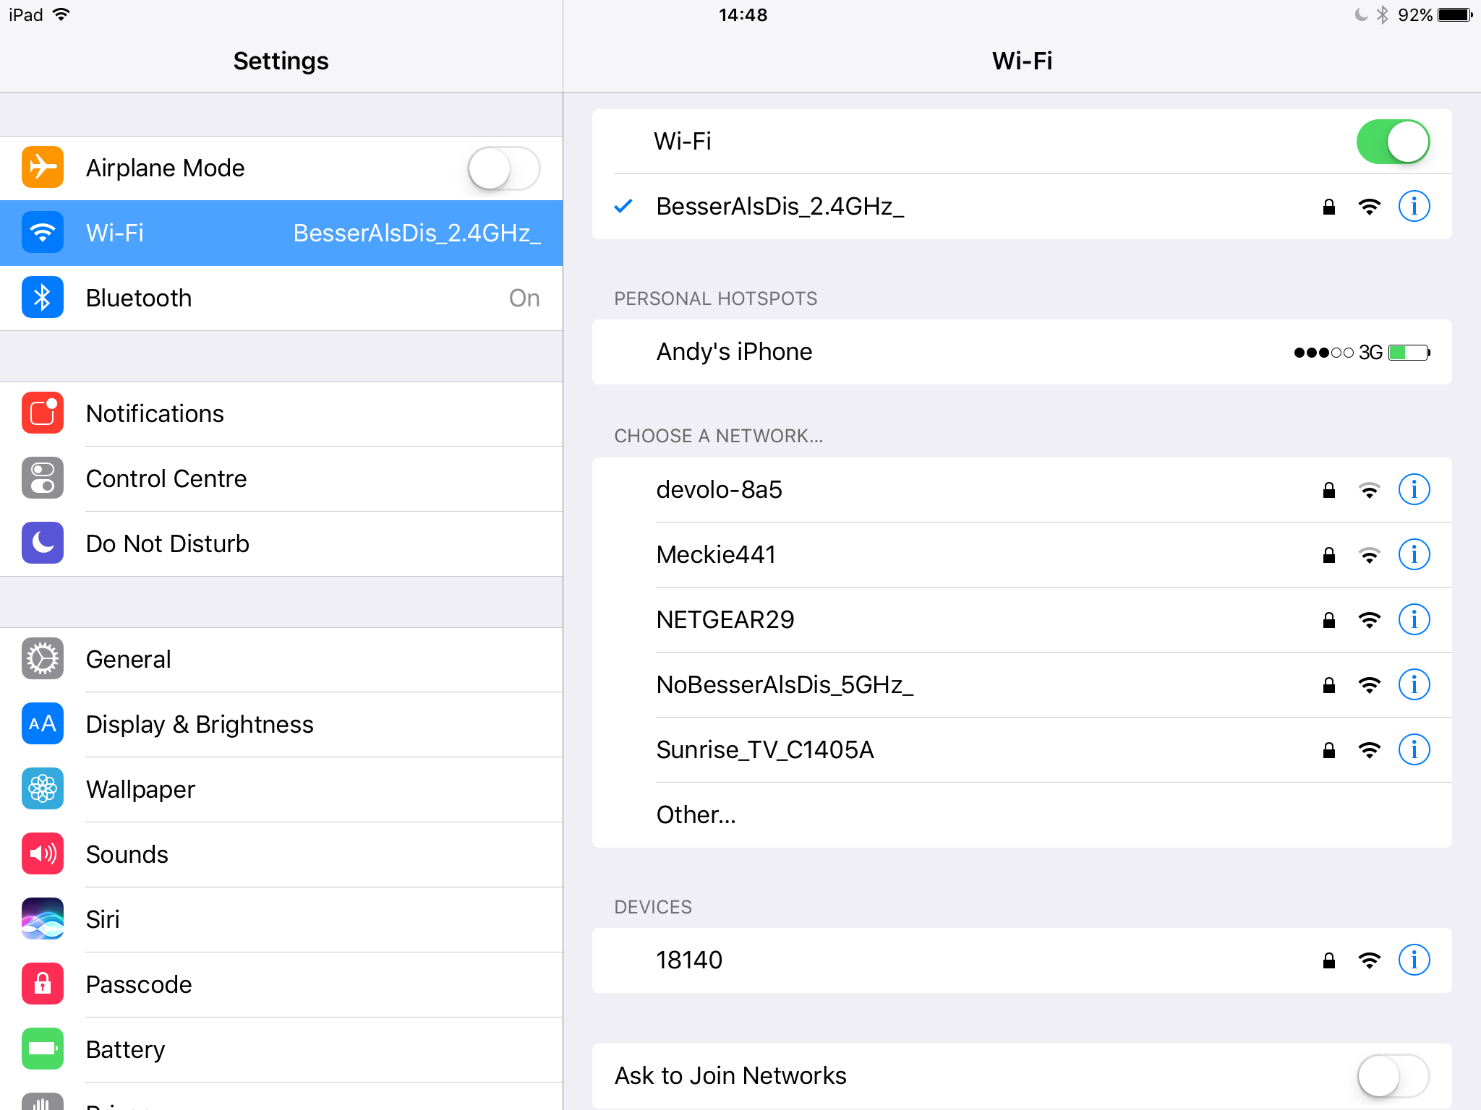

Image 1: Select Wi-Fi Network

After you connected with the wireless network, click on the small info button of the spectrometer wireless network.



In the IP-ADDRESS section select **Static**. Then enter a valid IP Address and Subnet Mask for this connection. The IP Address must be in the same network as your Spectrometer IP Address.

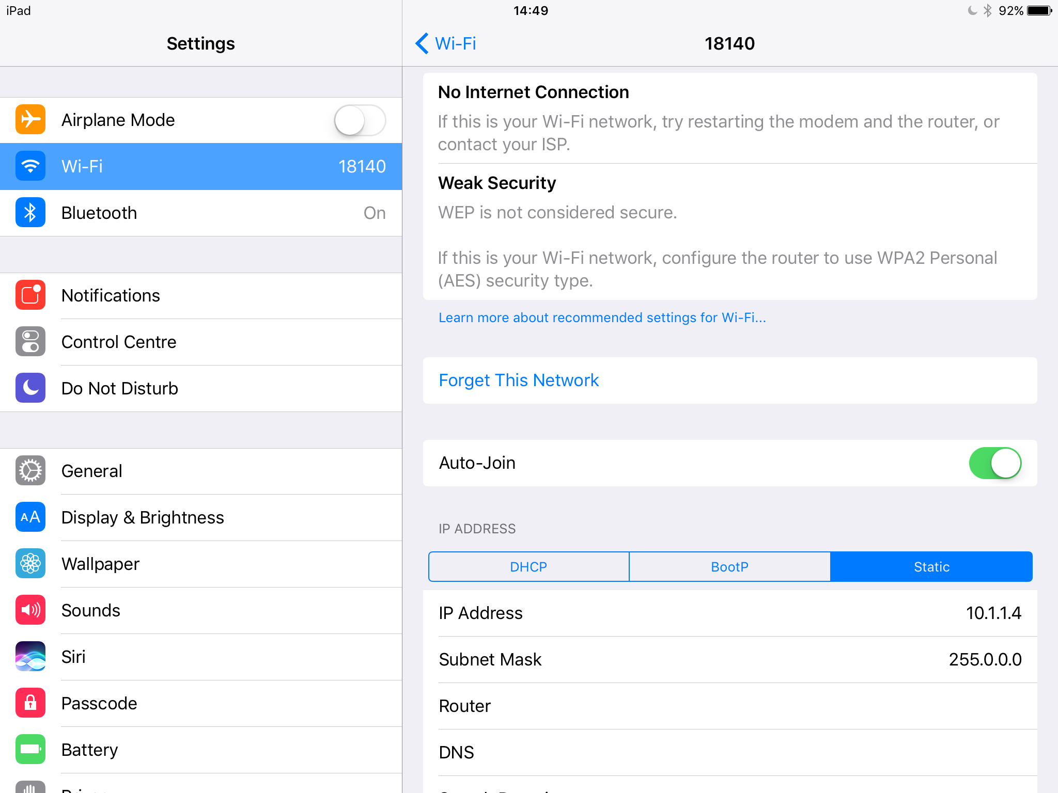

Image 2: Set IP Address and Subnet Mask

You are now connected with the device. During this connection, you do not have access to the internet.

# Calibration File Import

To import a calibration file into the spectrometer app, please tap the **Share Button** on the file you want to import. You can import the file from every app (except iCloud Drive) which can export files. For example, the Mail-App or the Dropbox-App. In the share menu tap on **Open in**. In some cases, this step is not necessary and you find only the **Import with Spectrometer** button.

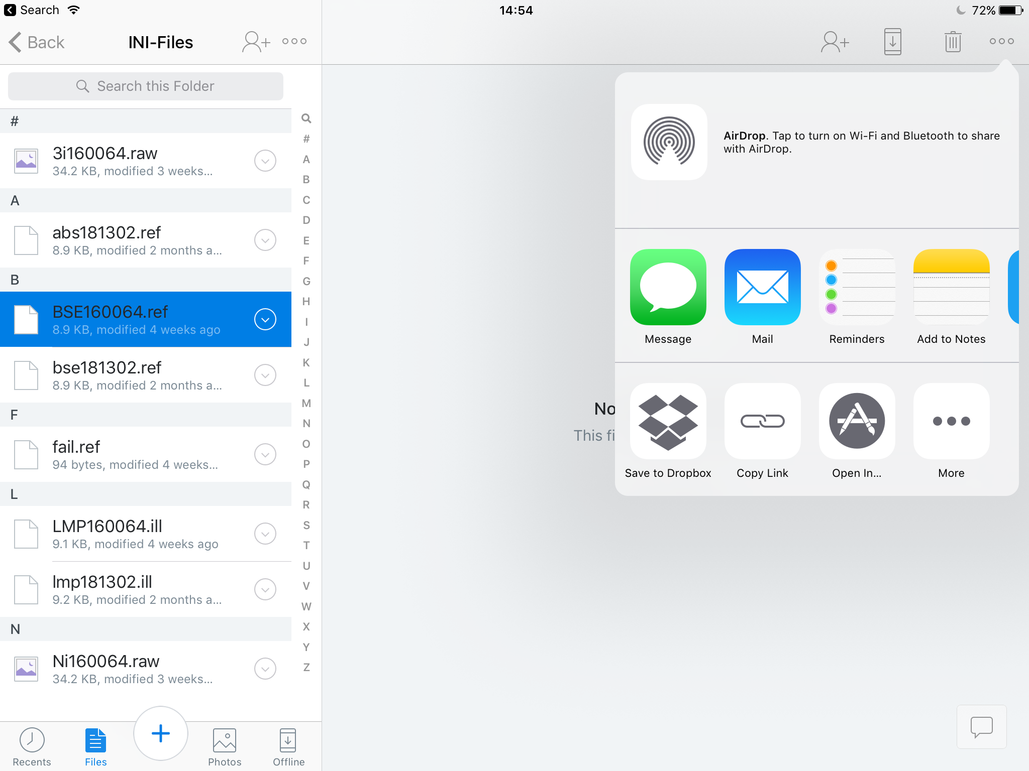

Image 1: Import from Dropbox

You will then see a variety of apps which can import this type of file. Select the Spectrometer-App.

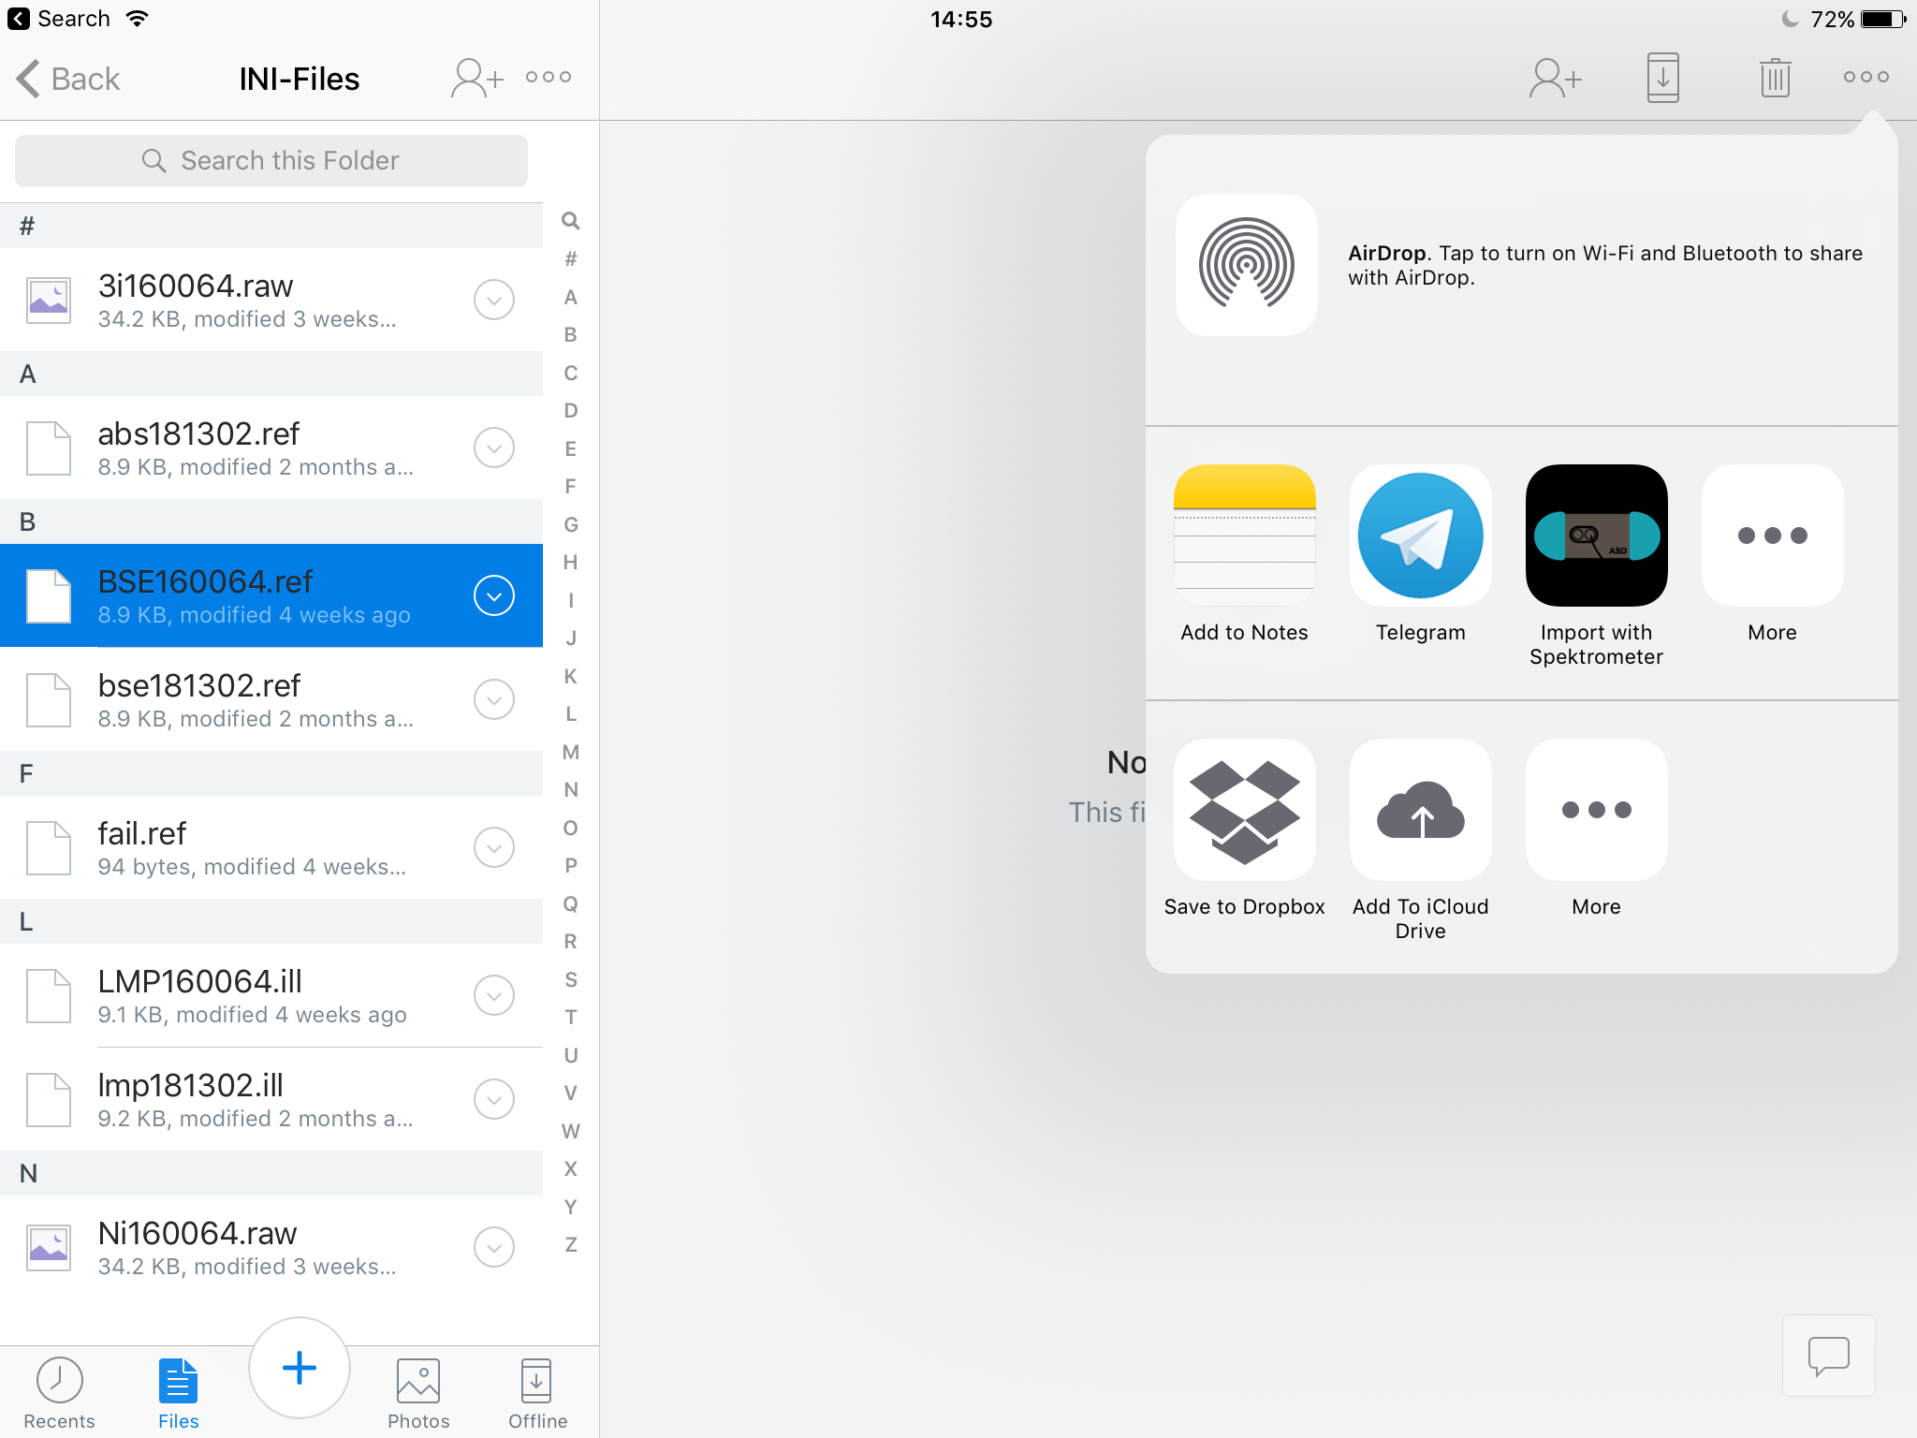

Image 2 Import from Dropbox

The Spectrometer-App will open and import the file. Now you can select this imported file for calibrating a Spectrometer.

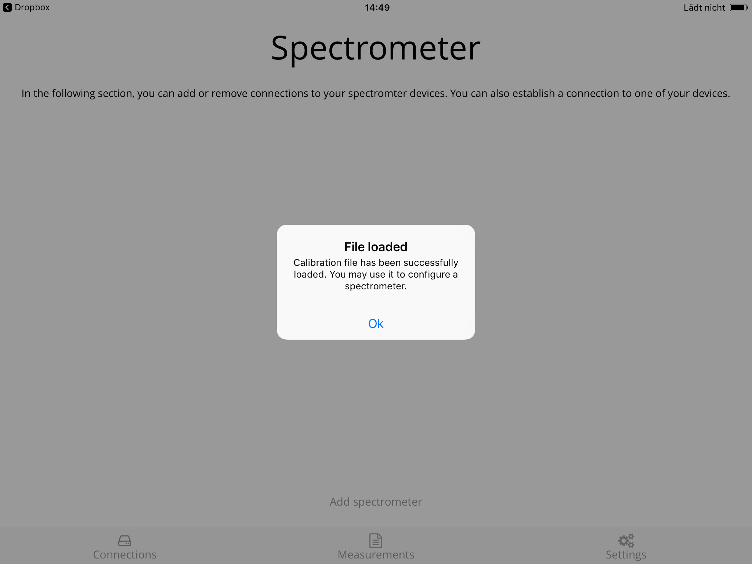

Image 3: Successful imported file

# Start page

The Start page lists all stored connections. If you want to add a connection tap on the **Add Spectrometer** button. This will open a new pop up.

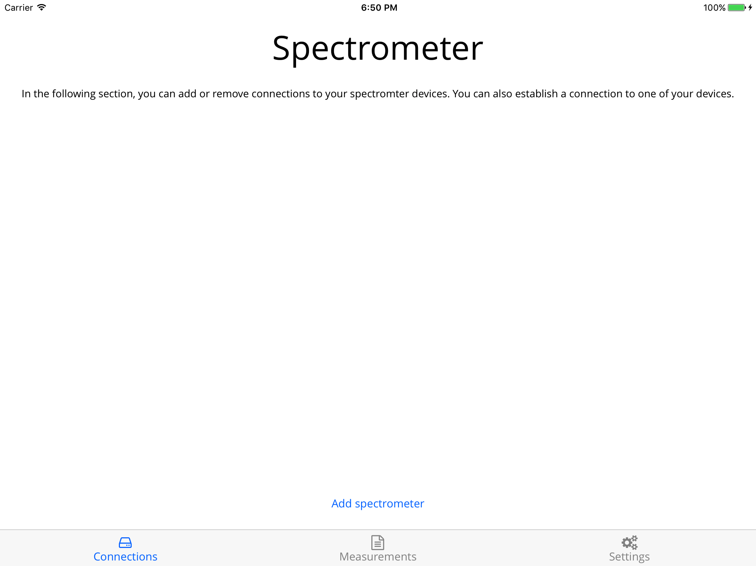

Image 4: Start page

# Add Spectrometer

Fill all fields on the showed pop up to save a new connection. All fields except Absolute Reflectance and Foreoptic are required.

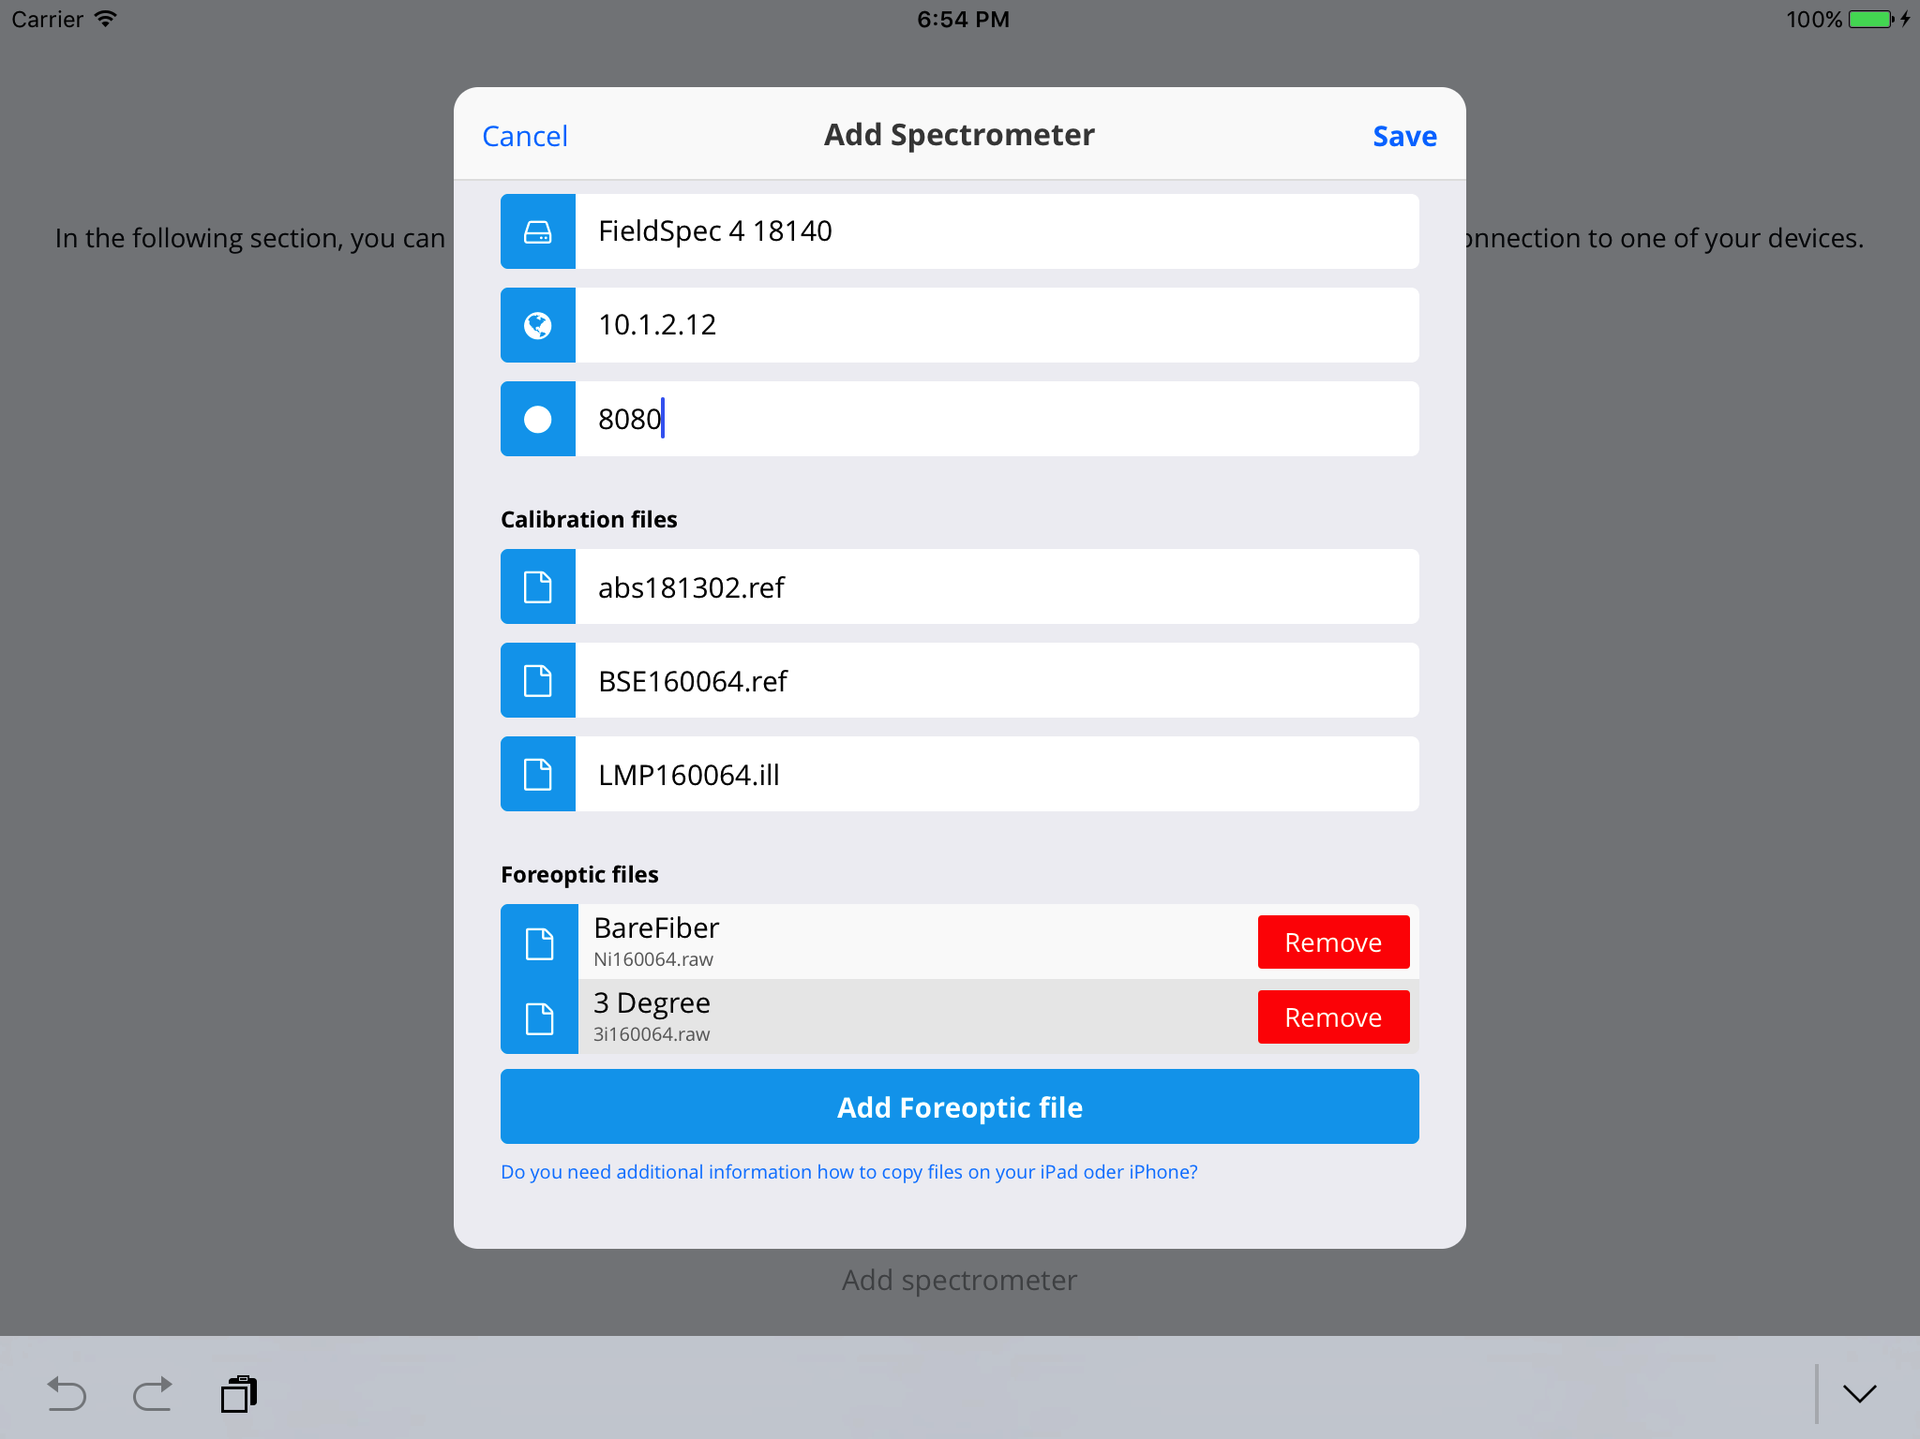

Image 5: Add spectrometer connection

# Connect

After adding a connection, it is time to connect to the device. Please make sure to power on the ASD device and wait 30 seconds before you proceed. Then you can tap the **Connect** button to establish a connection between the app and the spectrometer.

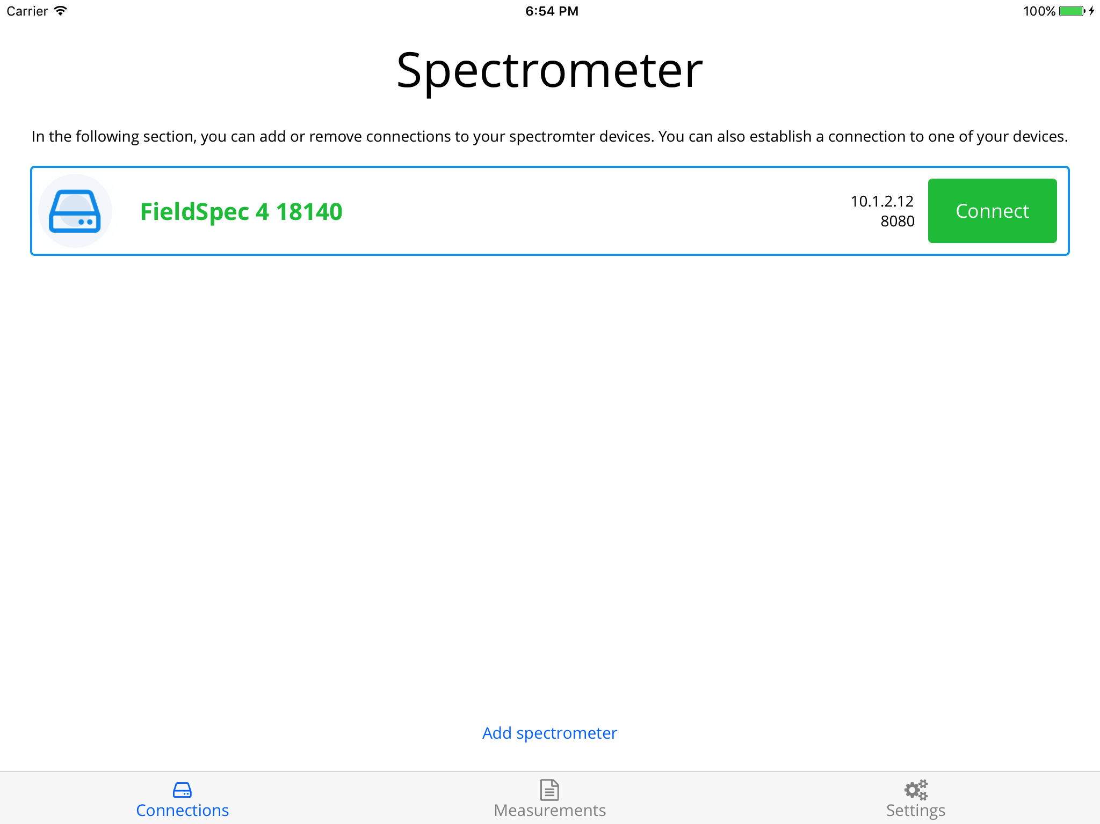

Image 6: Start page

Please mind that this step can take a few seconds. The app will open a connection and request a restore, initialization and a dark current.

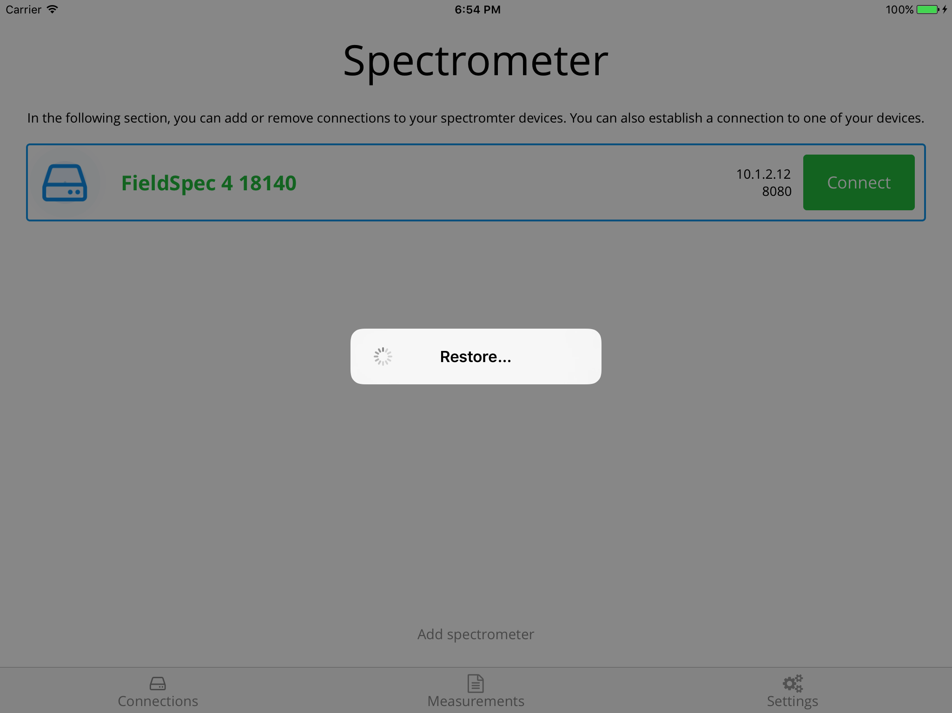

Image 7: Connect

# Acquire Screen

If the connection is successfully established and all necessary initializations are done, you will see the main acquire screen. This screen is meant to do some practice before doing a relevant measurement.

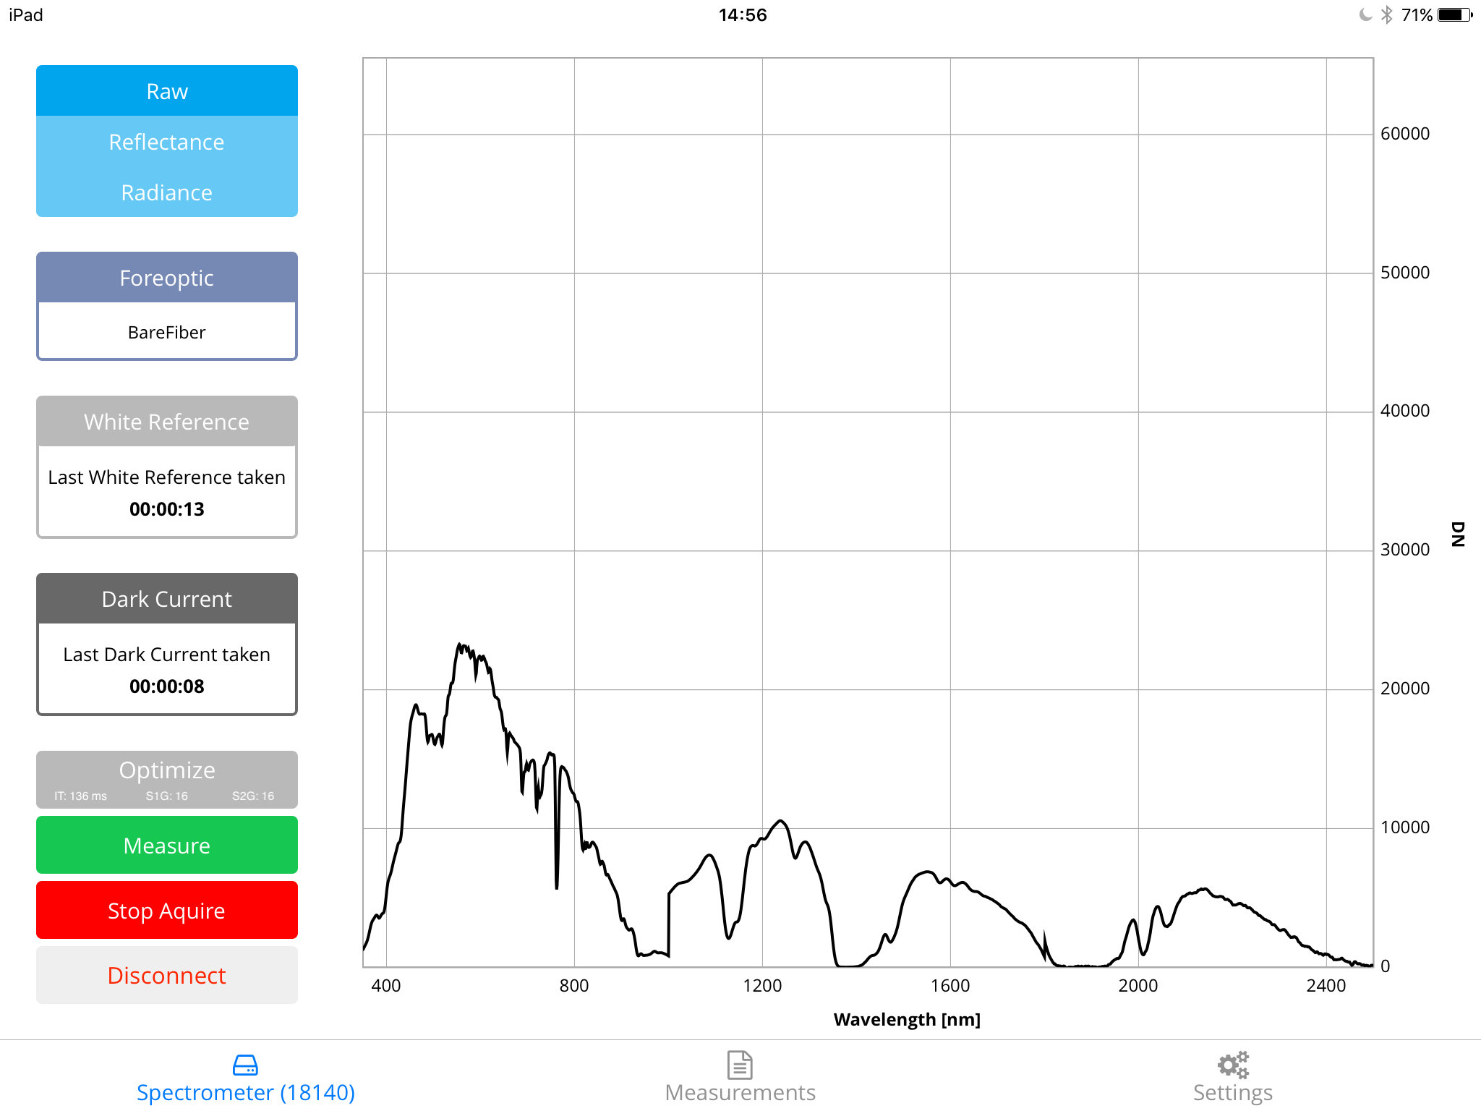

Image 8: Acquire screen

The navigation on the left side gives you the opportunity to change your measurement parameters.

First there are three buttons to choose the measurement mode. Raw is the default mode. Reflectance is only enabled if a white reference and dark current is made. And Radiance uses the last dark correction to calculate the correct values.

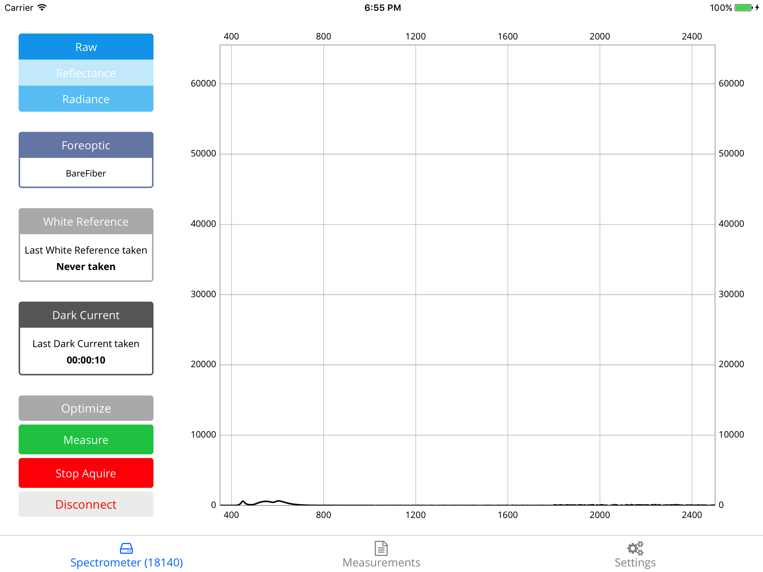

Image 9: Measurement mode radio buttons

On the next item, you can choose the Foreoptic you want to use for the measurements.



Image 10 Foreoptic button

White Reference and Dark Current shows the time since they were last taken. The format is “hh:mm:ss”. Please tap on the corresponding button if you want to take a new reference or dark current.



Image 11 White Reference and Dark Current buttons

In the next section, you see the following buttons:

* Optimize triggers an optimize action on the spectrometer
  + IT is the actual integration time
  + S1G is the actual Swir 1 Gain
  + S2G is the actual Swir 2 Gain
* Measure opens the measurement screen to record spectra
* Stop acquire pauses the acquire loop to take a closer look at the current spectrum
* Disconnect will close the connection to the spectrometer. You will be redirected to the start page.



Image 12 Action buttons

On the right-hand side, there is a zoomable chart for displaying the current acquire.

# Measurement Screen

When you open the measurement screen, you can enter some basic information for the measurement. These inputs will be stored for the next measurements.

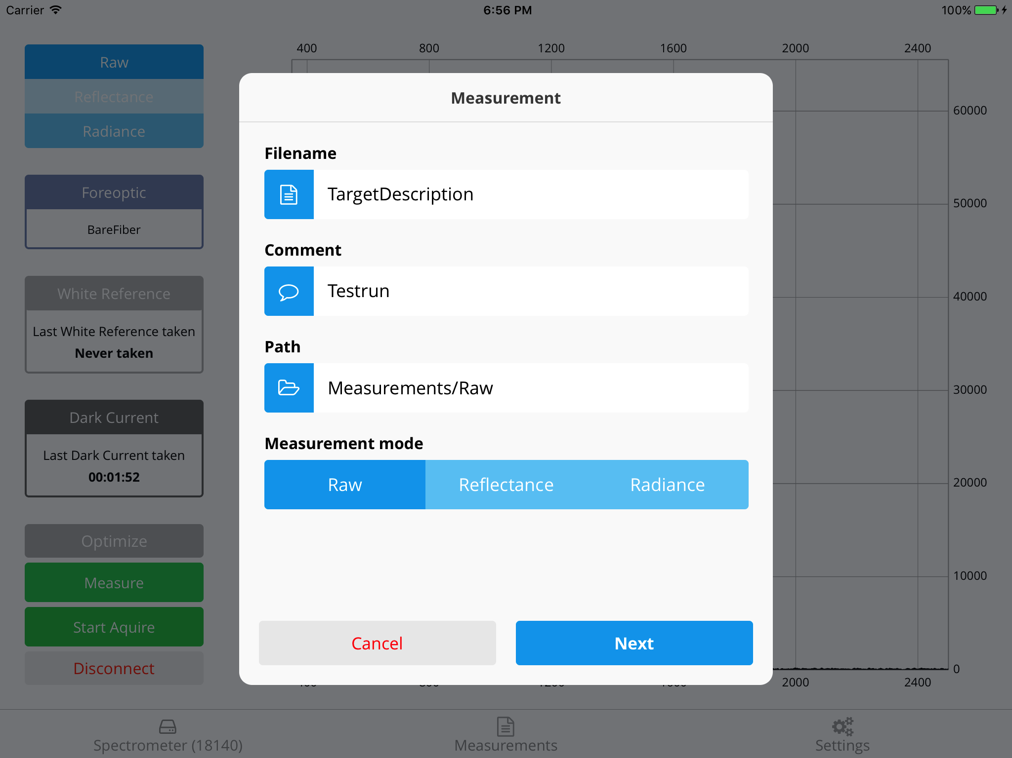

Image 13: Measurement start

When you tap on the path input, a file browser opens and you can create new folders.

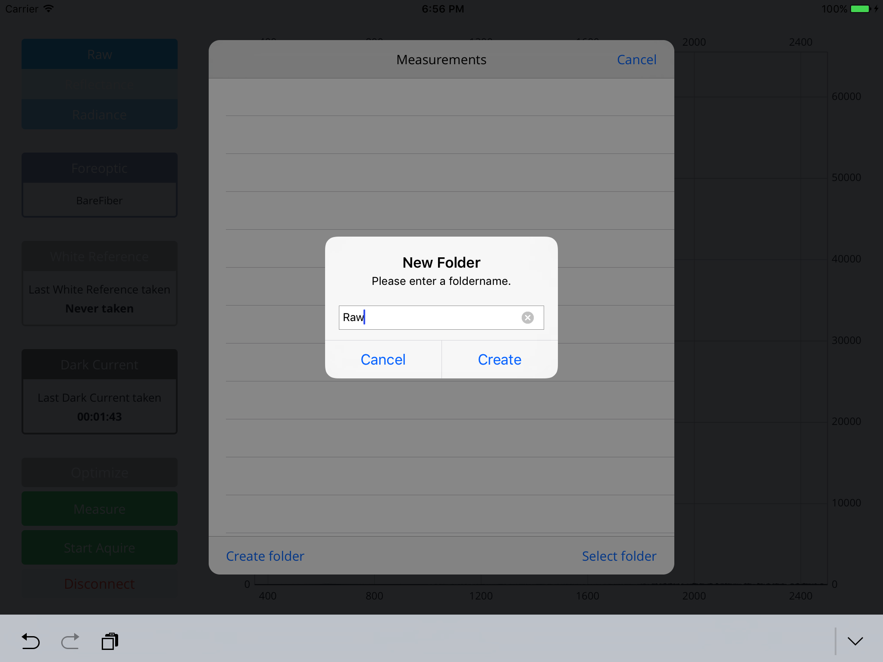

Image 14: Measurement file browser

Each mode has its own process-flow. When you go to the next page the corresponding settings will be displayed.

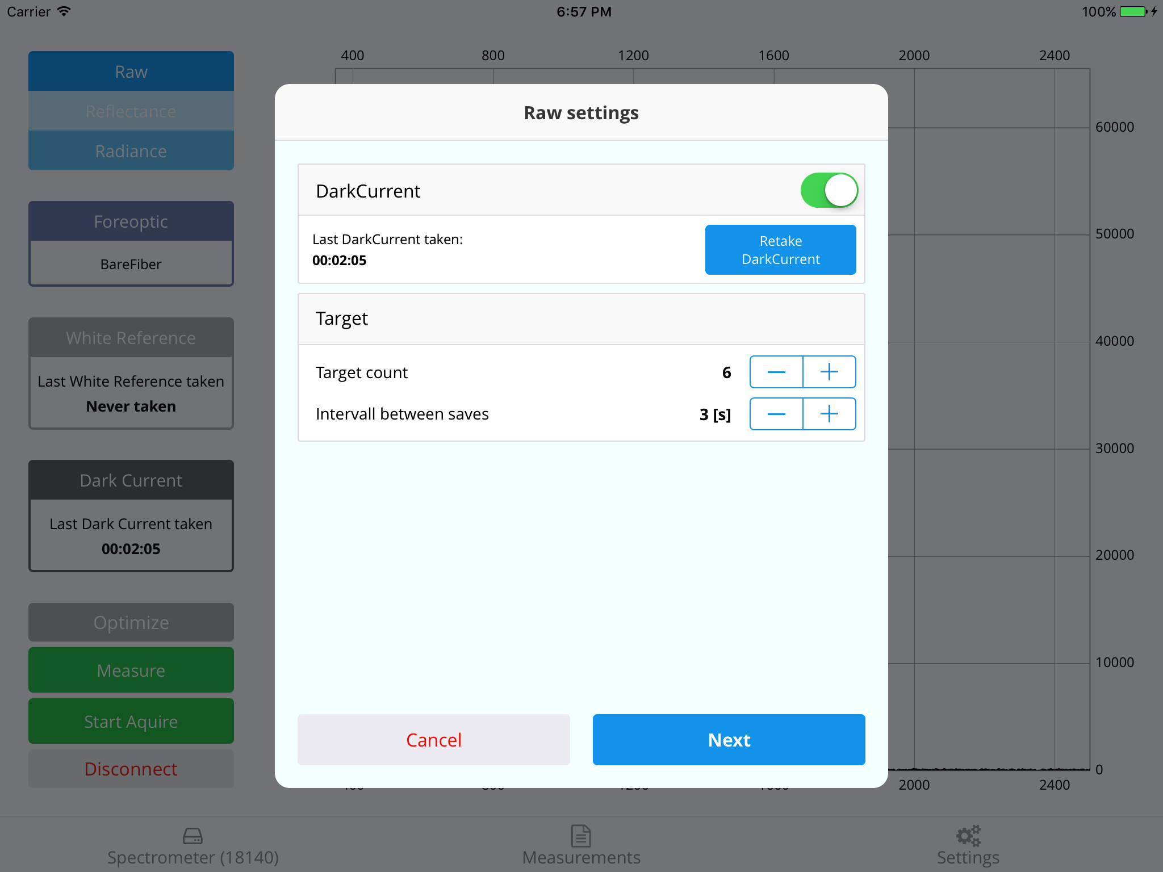

Image 15 Raw Settings

Each setting does have a target section where you can set the count of acquires on the target and the delay (in seconds) between this acquires.

When you click next a chart will display the current spectrum input on the ASD device.

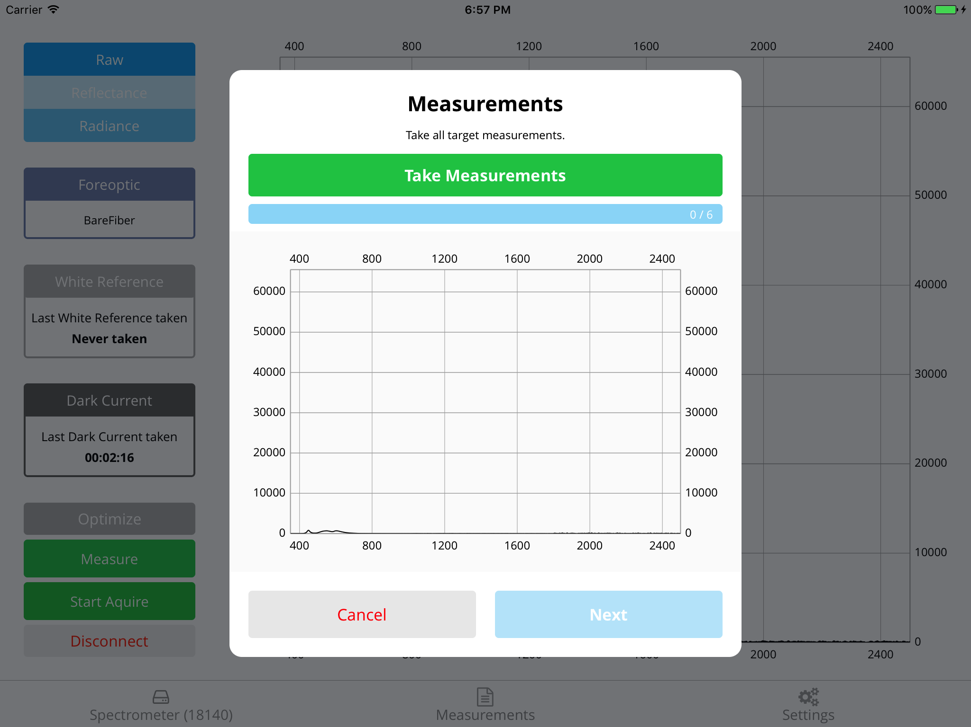

Image 16 Target acquire

Now align the Foreoptic and tap “Take Measurements” when you are ready. The measurement progress is shown below the button. After the measurements, you can switch to the next page.

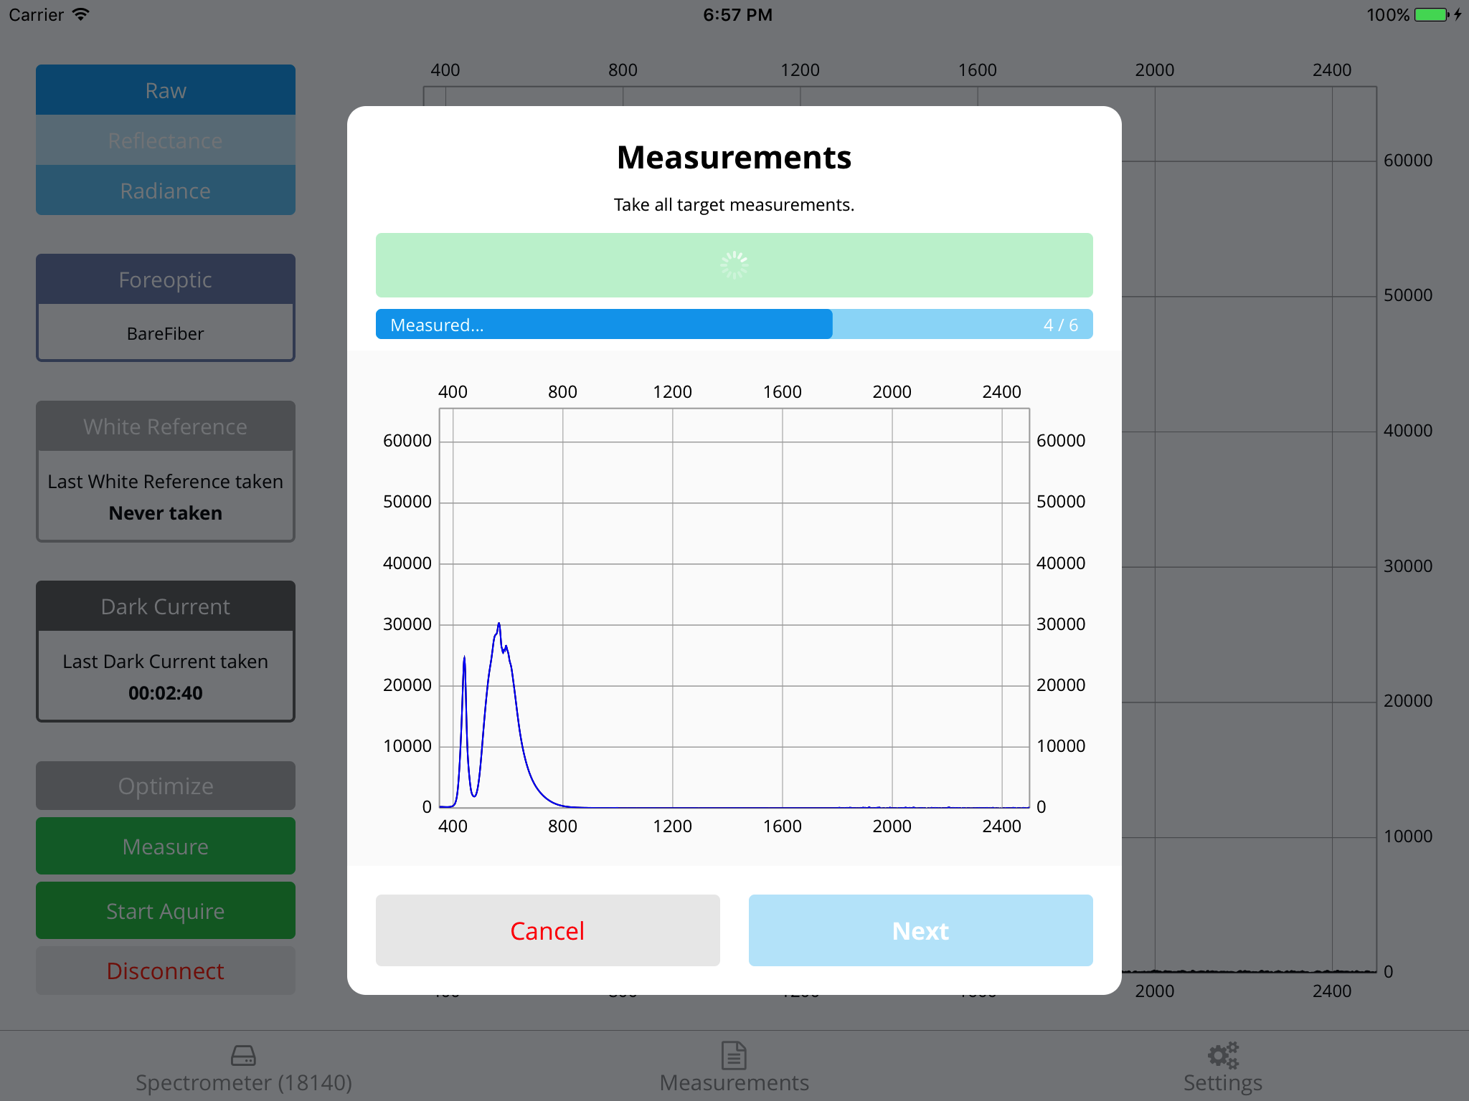

Image 17 Target acquire

After all measurements are successfully saved you will see the finish screen.

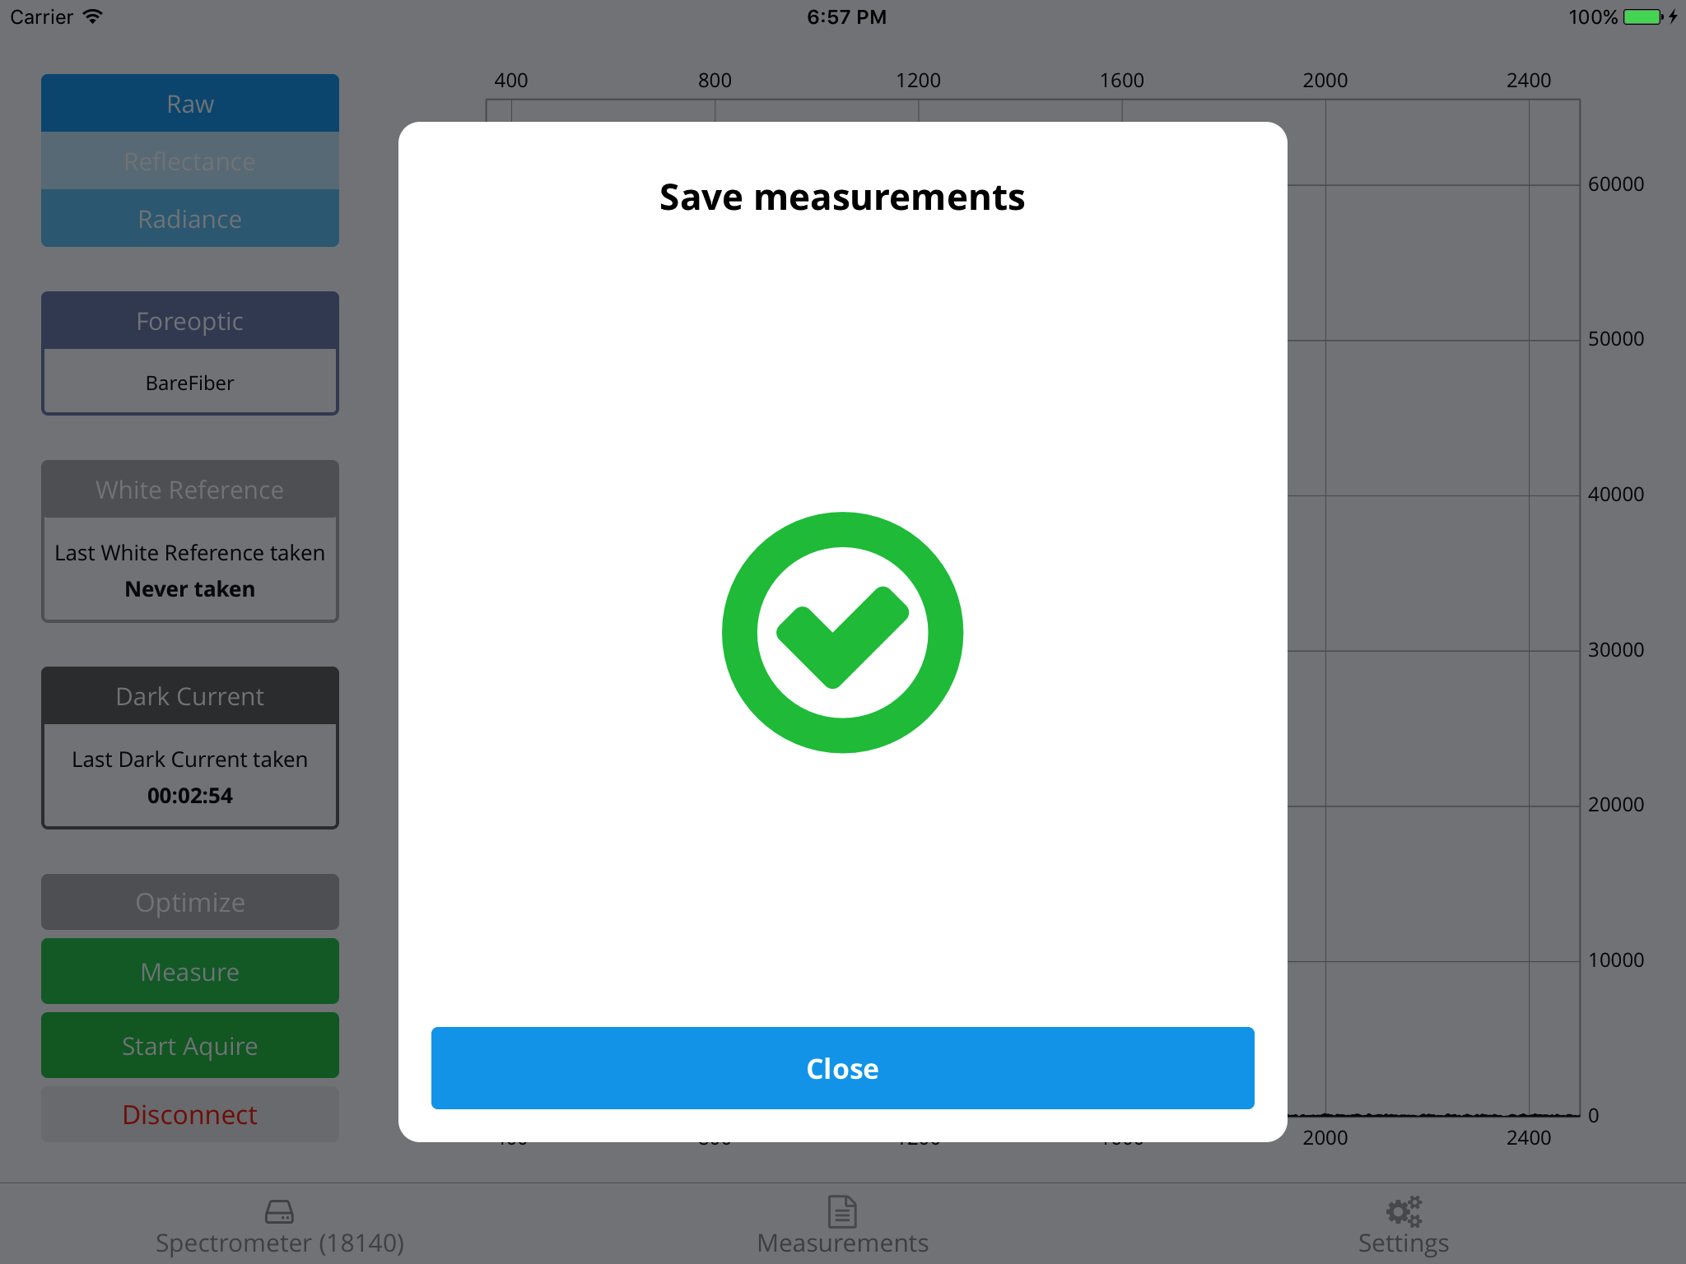

Image 18 Finish measurements

Tap close and select the measurements tab.

# Measurements

On the measurements tab, you can choose your stored files on the left side of the screen. As soon as you select a file it will be shown on the right-hand side.

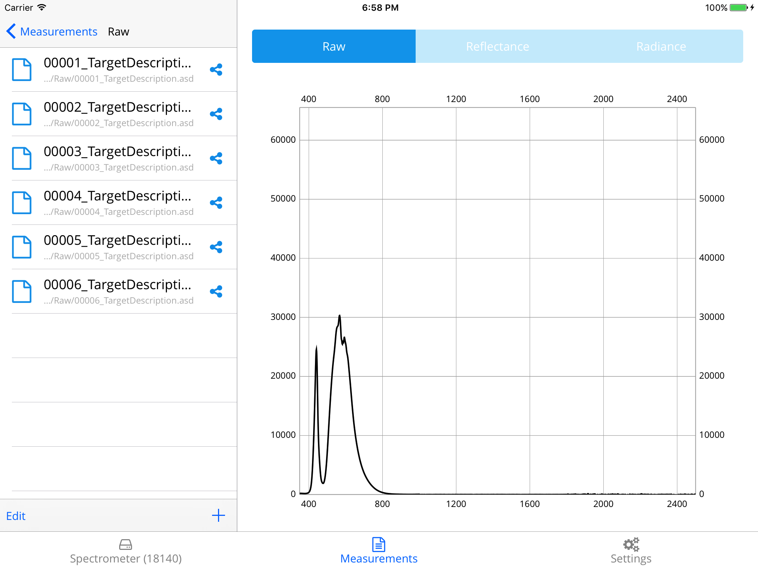

Image 19: Measurements view

If the Measurement was taken in Reflectance or Radiance mode you can choose the display as well.

# Export

If you want to export a file, click on the share icon next to a folder or file. A pop up will show up. In this window, you can choose the export destination app.

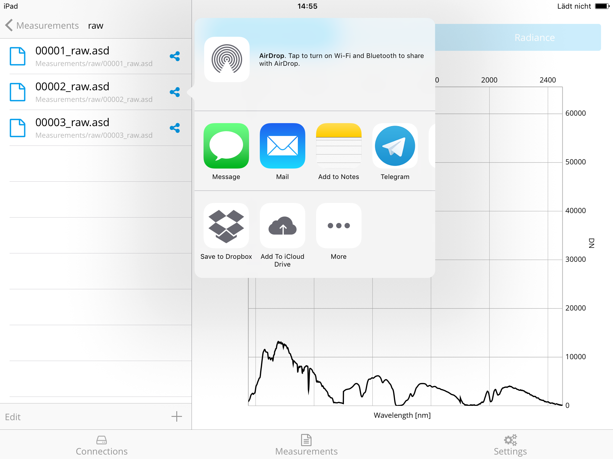

Image 20: Export file

The selected app will present a new view where you can save or send the file.

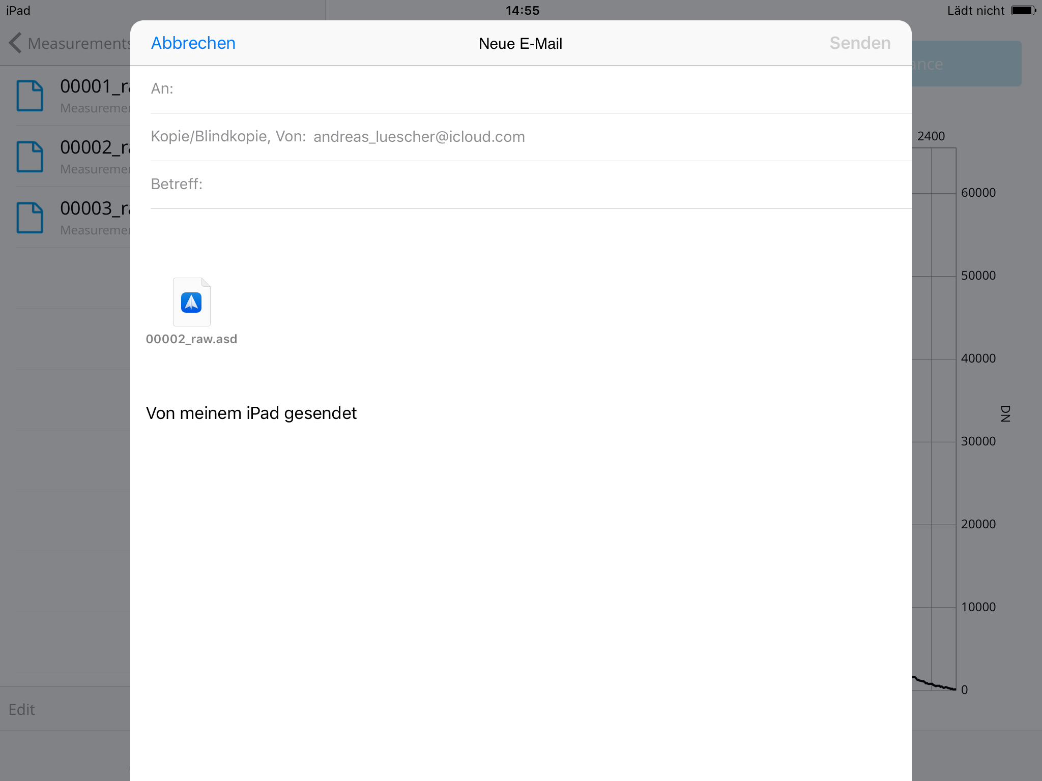

Image 21: Mail exported file

# Settings

The settings are divided in 4 sections. Under the General section, you can erase all your measurement settings (last filename, last comment and last file path).

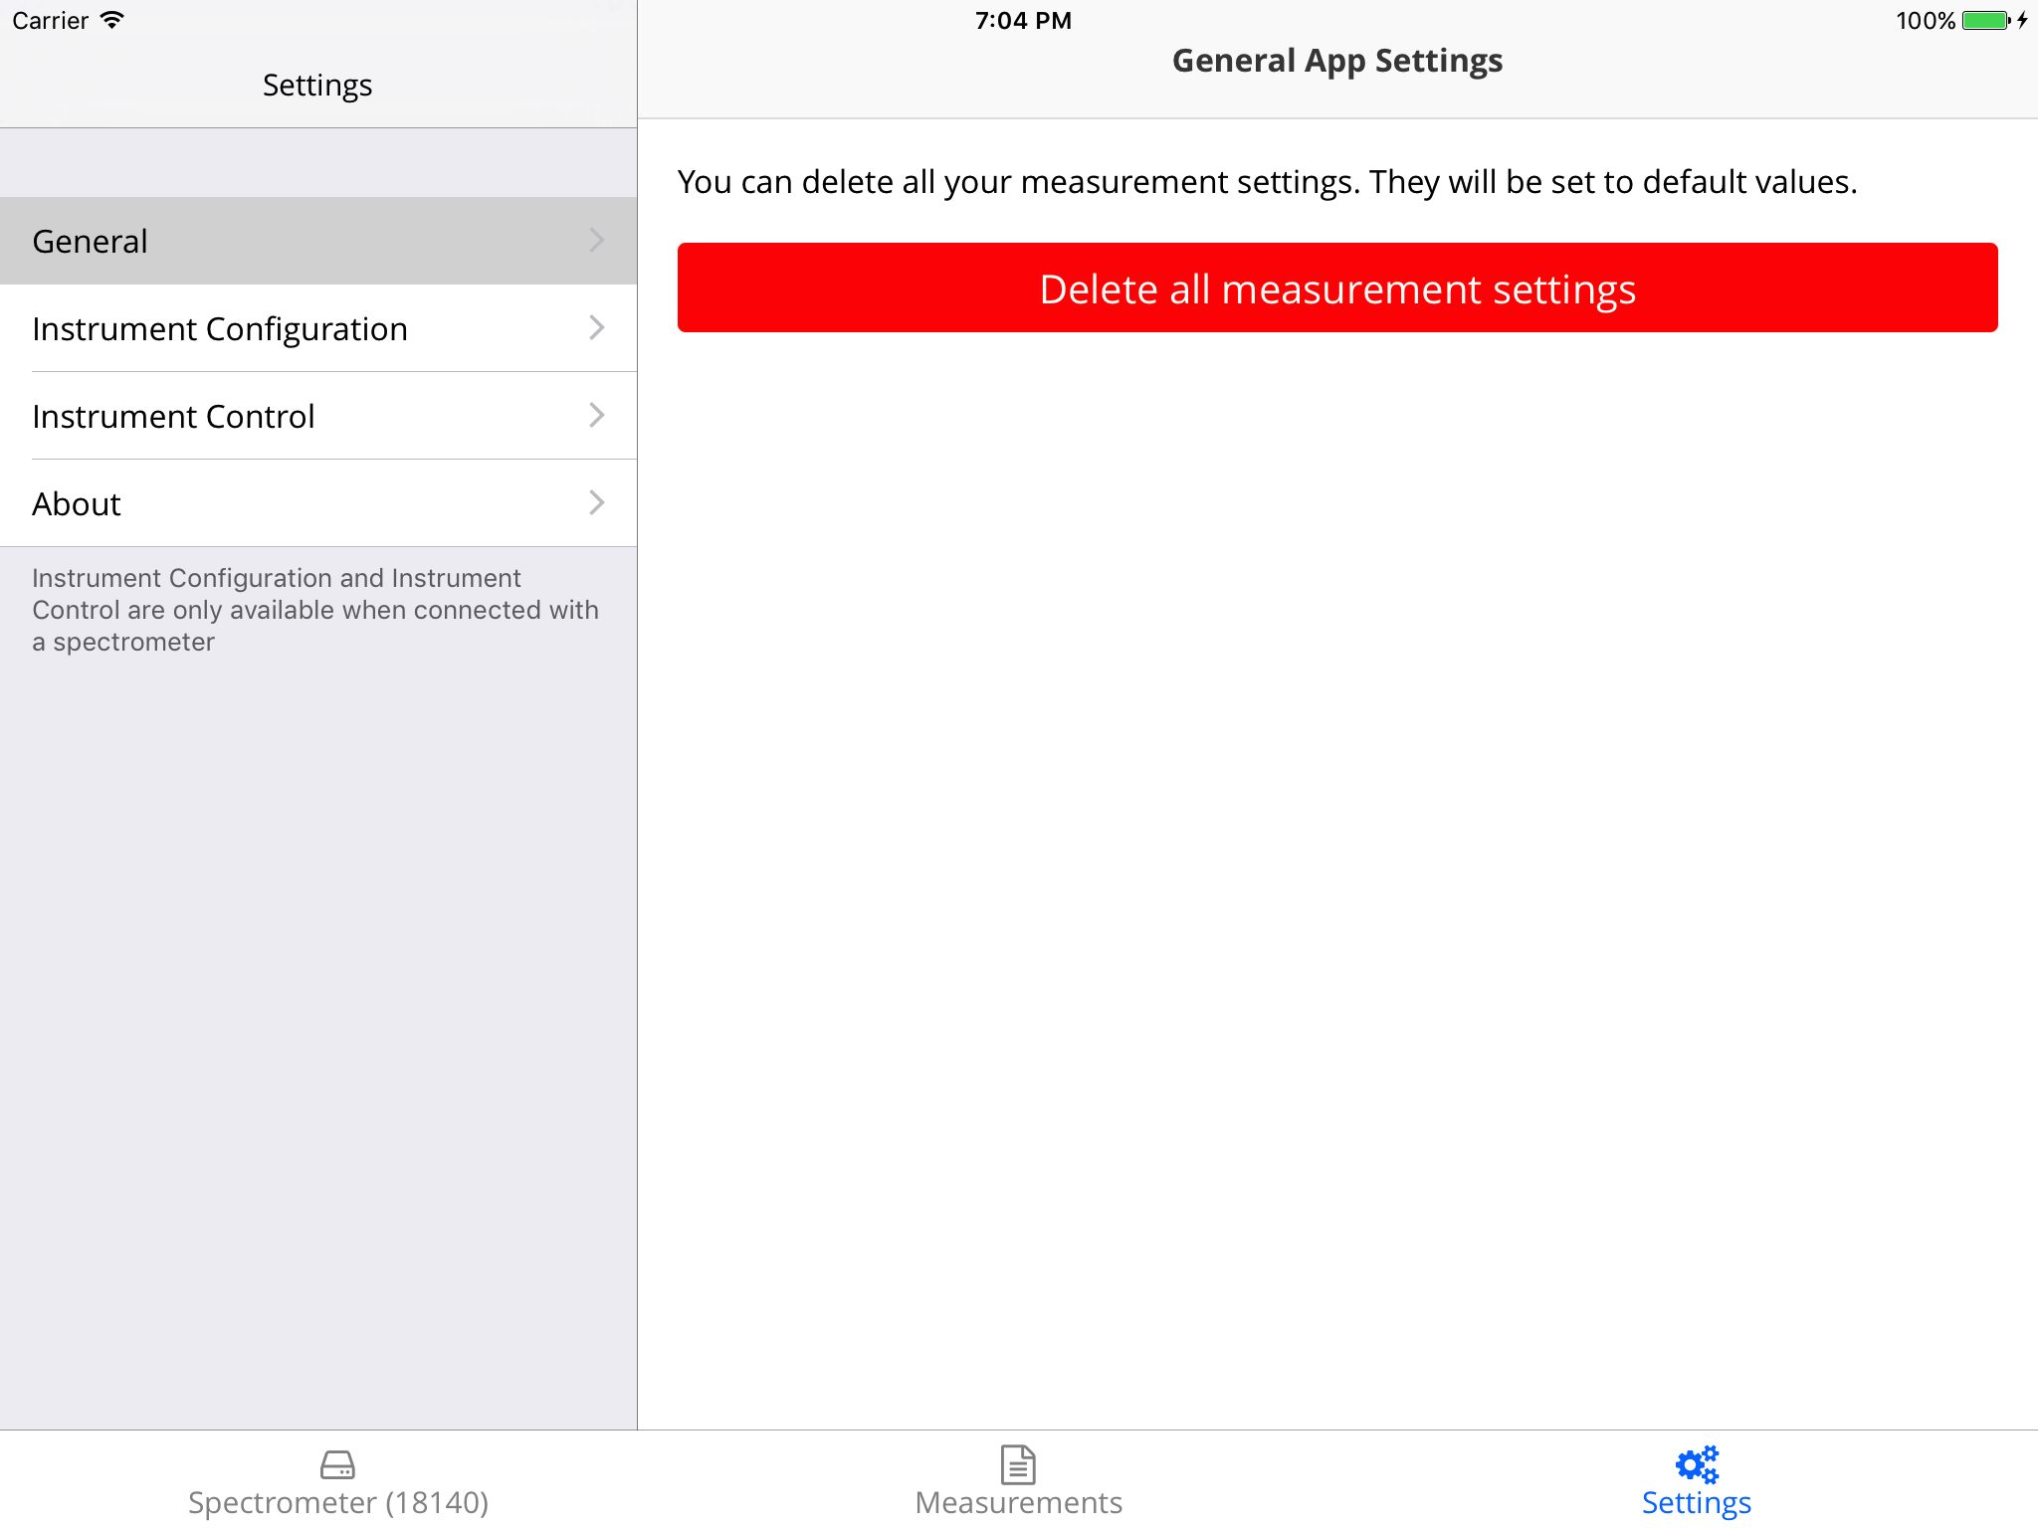

Image 22: General settings

Under the Instrument Configuration section, you can set the Sample counts for a spectrum acquire, a dark current and a white reference.

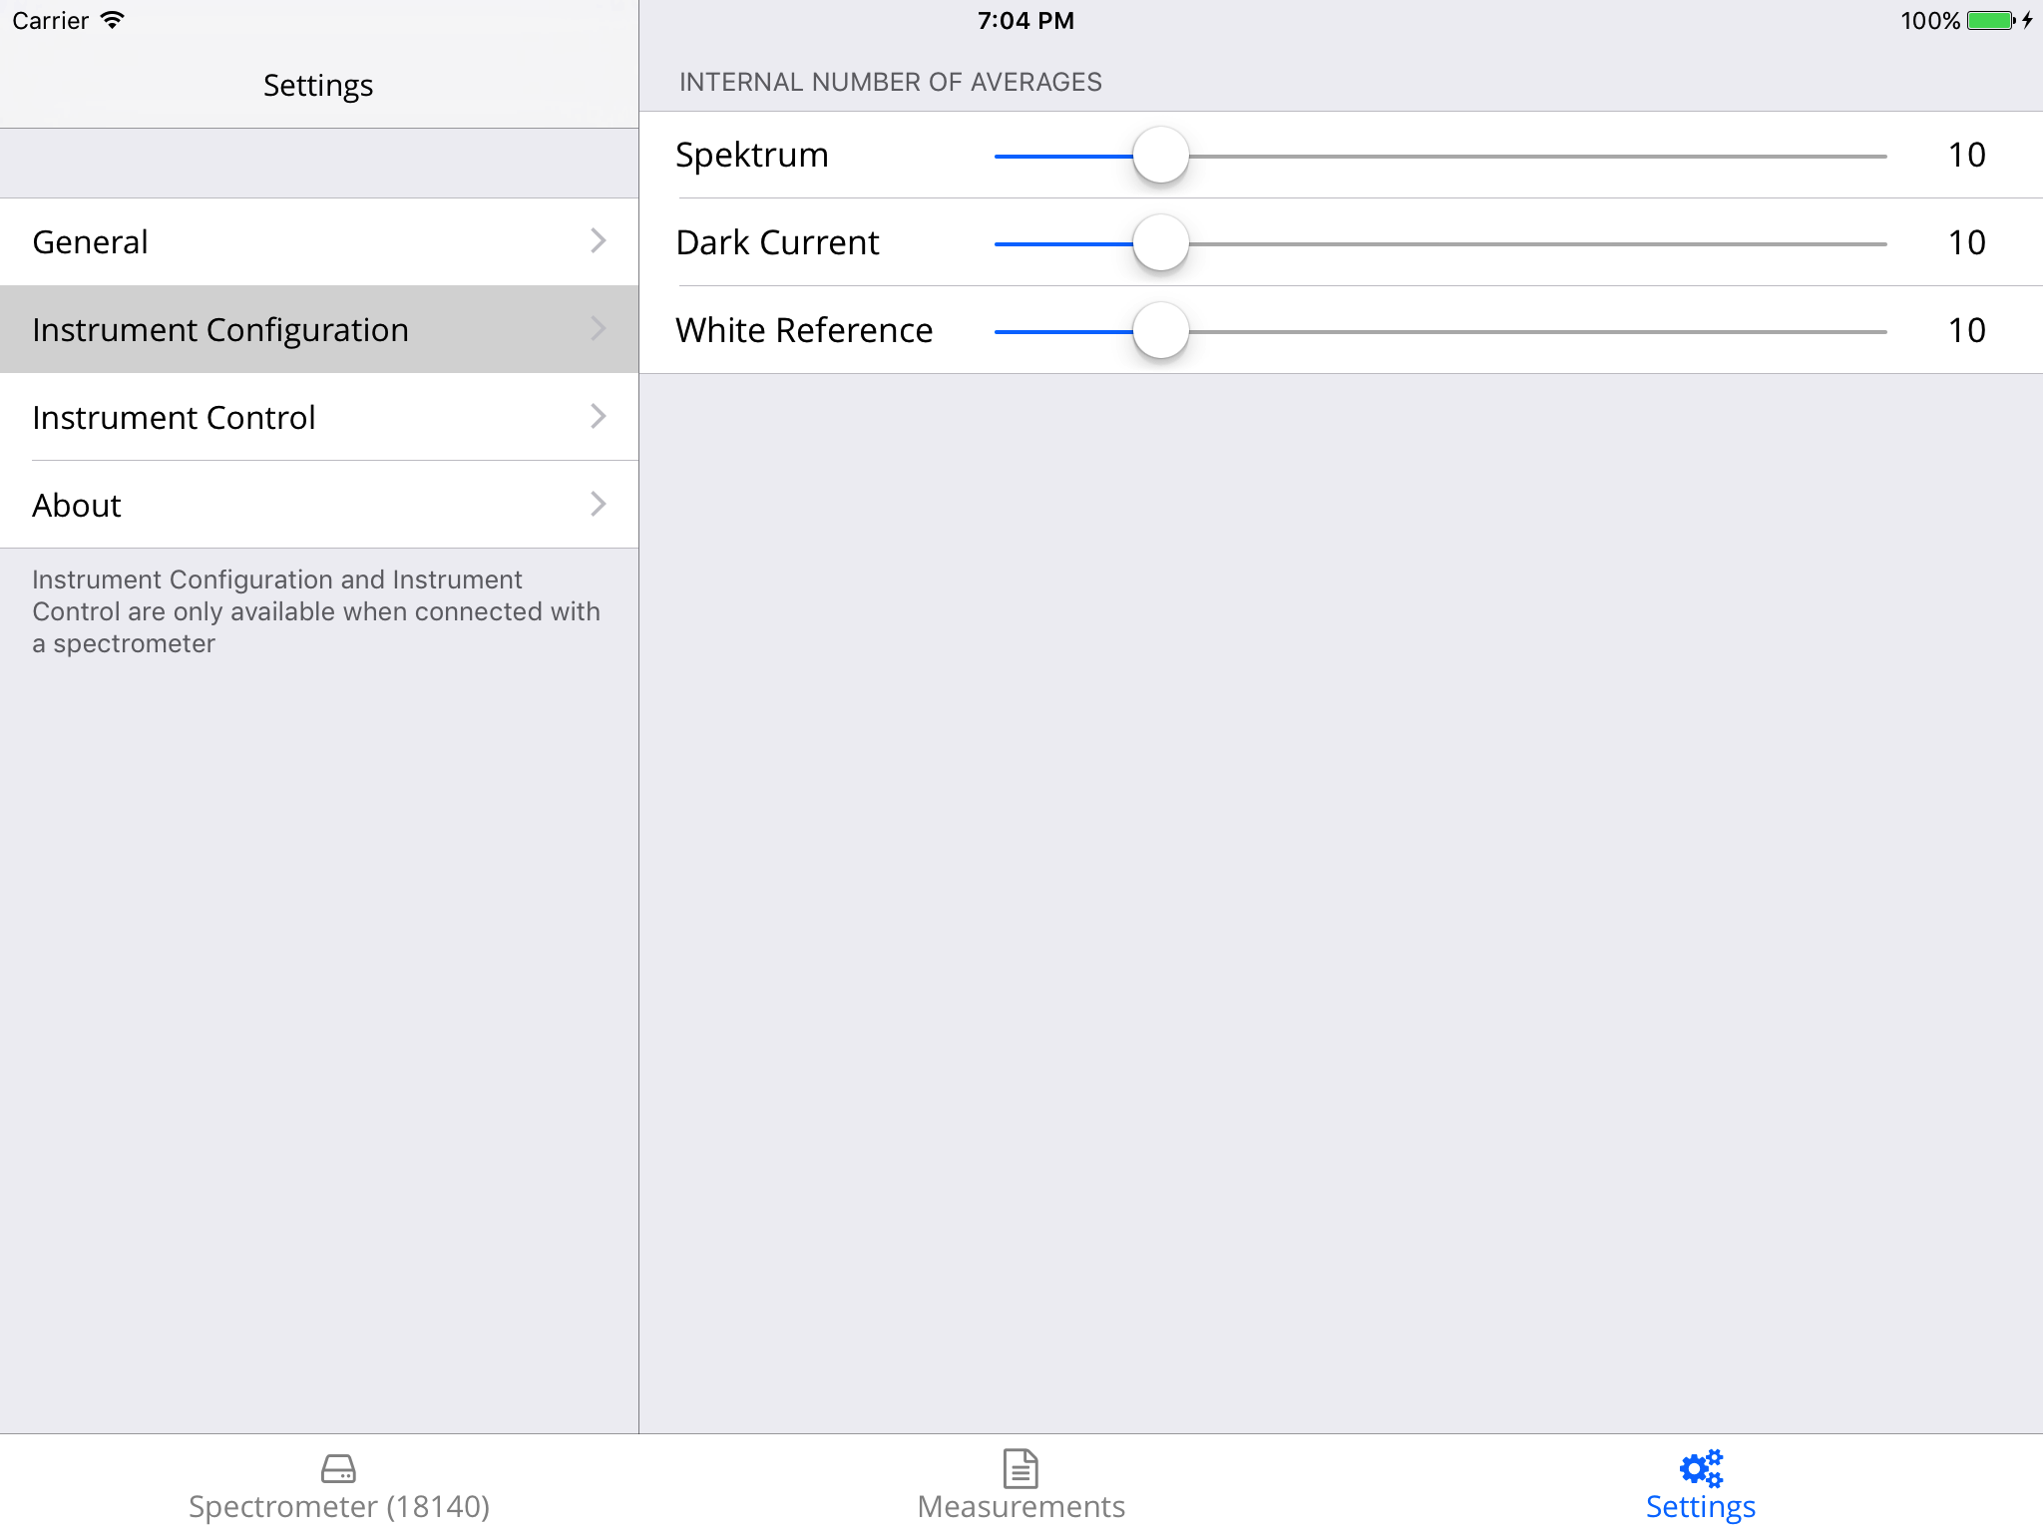

Image 23: Instrument Configuration settings

The Instrument Control section loads the current integration time, the gains and offsets of the SWIR sensors. You can override the actual settings or trigger an optimization.

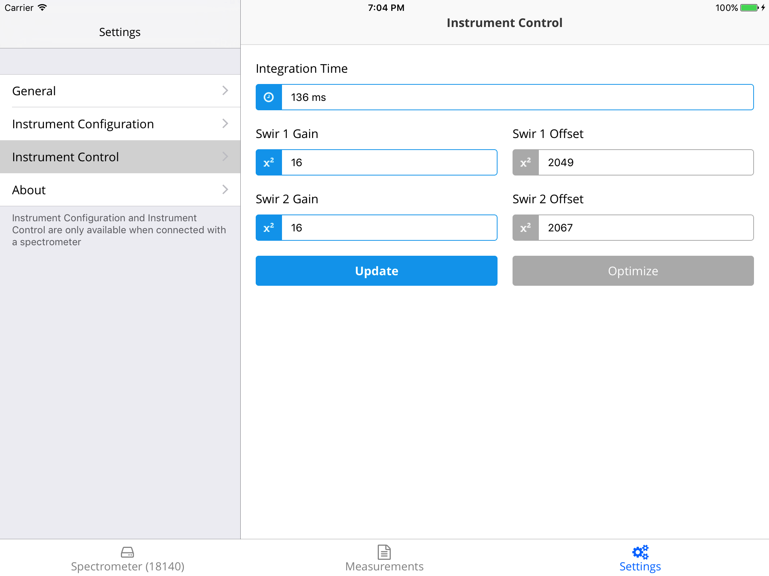

Image 24: Instrument Control Settings